Glossary

#### Quick links

* [www.workers.coop](http://www.workers.coop) – website
* [office.workers.coop](https://office.workers.coop/) – All our files stored (Nextcloud)
* [forum.workers.coop](https://forum.workers.coop) – Discussion forum
* [Strategy presentation](https://docs.google.com/presentation/d/1H3zRyvG25CEYLEnMdY8ks50z0uG181DWEqVBIVpv8Hs/edit#slide=id.g15d82957701_0_317) – Our strategy
* [Guide to working groups](https://office.workers.coop/s/ew9ZWMa32LB3tAn) – How to start and run working groups
* [Glossary](https://office.workers.coop/s/tt8WM7emHY82DrF) – Terms and how we define them

Table of Contents

Quick links 1

Consent Decision Making 1

Coordination Group 2

Co-operative Enterprise members 2

Delegate 2

Discourse 2

Domain 2

Facilitator 2

Operational Agreement 2

Policy 2

Policy Co-Creation 2

Round 2

Selection Process  3

Sociocracy 3

Sub-Group  3

Supporter 3

Working Group 3

Worker member 3

#### Consent Decision Making

Those involved will work together to make a decision that, whilst it may not be the preferred option of all, falls within the tolerance of all (i.e. something everyone can work with). If consent cannot be achieved, then those involved should consent to a course of action that refines the decision and/or aims to address the concerns of those who cannot consent. This may include further research or (where appropriate) a limited trial period of implementation of the decision. The guiding principle being that the decision should be **good enough for now and safe enough to try**.

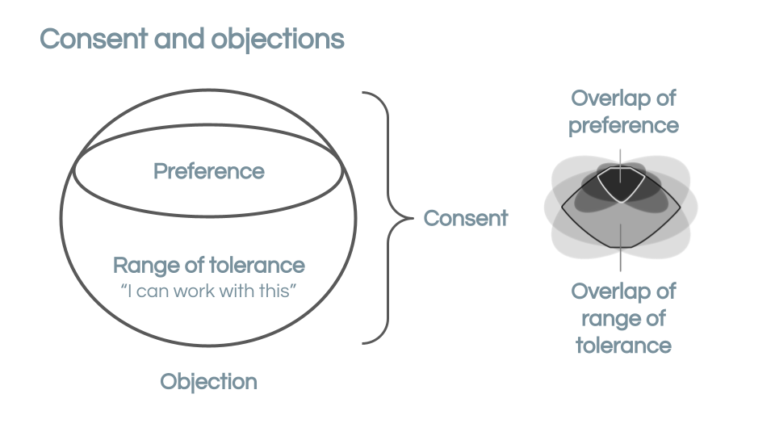

#### Coordination Group

This Group is composed of representatives from Working Groups as well as a representative from the Board. This Group is responsible for coordinating the operational work of the workers.coop.

#### Co-operative Enterprise members

These are worker co-operative or employee-owned enterprise members of the federation or other organisations with significant worker control.

#### Delegate

Delegates act as the link between the Working Groups and the Coordination Group in the workers.coop's structure. They are tasked with maintaining information flow and supporting effective decision making in their Working Group and in the Coordination Group - they hold consent decision-making responsibilities in both meetings.

#### Digital platforms

The term we use to refer to our online software that we use to organise, including NextCloud, the Forum and our Wordpress site. Our Information Sharing Policy ensures that all members have correct and open access aligned to their needs.

#### Discourse

The opensource software we use to run our main communications platform - <https://forum.workers.coop/>

#### Domain

The list of all the areas each Group holds responsibility for and has decision-making authority over. Every Working Group shall have a document defining its domain.

Driver

Drivers coordinate the work of their Working Group, and are the external point of contact.

#### Facilitator

Facilitators prepare agendas for their Working Group and hold responsibility for ensuring all members are able to actively contribute in meetings. Facilitators are also tasked with following appropriate processes in line with sociocratic principles.

#### Operational Agreement

An agreed guideline that outlines operational processes or practices that support the function of a specific Working Group. In contrast to policies, operational agreements apply only to work that falls within a specific Working Group’s domain.

#### Policy

A secondary rule that applies across the workers.coop. A policy establishes a principle or course of action that guides the work of the workers.coop. Policies may be proposed by any Working Group and are agreed either by the Board or taken to the AGM, as appropriate for the scale of the policy. Policies are owned by the Board, who hold ultimate responsibility for their enactment.

#### Policy Co-Creation

A process designed to enable workers.coop members to participate in democratic policy co-creation. Working Groups take responsibility for considering suggestions generated in the co-creation process from outside of their Group, but the final decision of what to include in a draft policy remains with their members.

#### Round

Speaking one-by-one in turn until everyone has spoken once.

#### Selection Process

Selecting members into Working Group roles through an open elections process using nominations and consent decision making instead of a secret ballot or volunteer system.

#### Sociocracy

Our approach to governance and decision-making is inspired by Sociocracy as an organising tool, based around consent (not consensus) organised through Groups (sometimes called circles) for our operational and day to day decision making.

#### Sub-Group

Where the domain of a Working Group becomes too large for the group to fully manage, they may decide to form a semi-permanent sub-group or groups to divide the domain.

#### Supporter

Although not currently defined in our membership policy a supporter is someone with a looser affiliation to workers.coop, someone who may take on some activity but has not committed to be part of a working group or taken up worker member membership.

#### Working Group

Working Group of named individuals whose members hold responsibility for the domain of the Group. Named Working Group members have consent responsibilities - they are the people with the right to make decisions as well as being held accountable for the decisions taken. Working Groups are connected to the Coordination Group.

#### Worker member

Everyone who is a member of a working group is eligible to become a worker member of workers.coop. Eligibility and the process for becoming a worker member is set-out in the membership policy.