**Beginner’s Guide to Workers.coop Platforms**

Setting up Your Account

In order to join the conversation at the workers.coop Federation and get involved with the various work opportunities, you need an account. You can do this by registering for a Single-Sign-On (SSO) account, which gives you access to all of workers.coop’s platforms without the need for multiple accounts*. The platforms include our Discourse Forum and Nextcloud (read more about these hereXXX).

Begin by creating a workers.coop account [here](https://auth.workers.coop/if/flow/enrolment-invitation/?itoken=933326bf-f3c9-40ab-99cb-3124e5fb45fd).

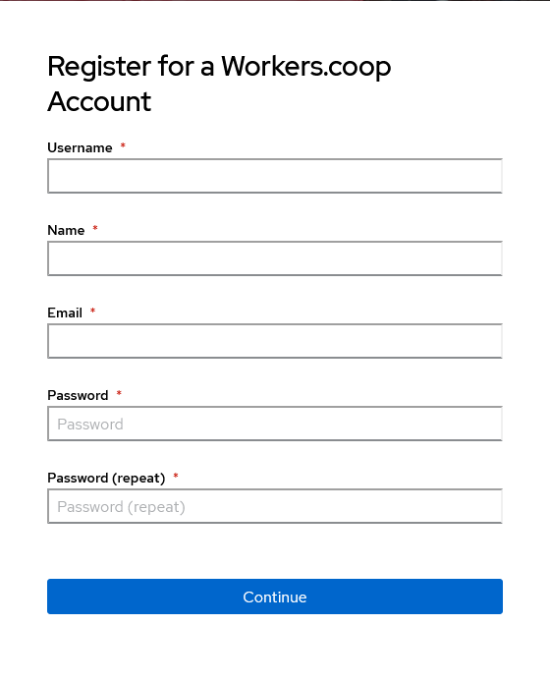

*Note: your password must contain 2 upper-case and 2 lower-case letters, 2 numbers and 1 special character.*

* It is possible to create unique accounts instead for each platform. If you want to only access the **Discourse Forum**, go to <https://forum.workers.coop/> and click ‘Sign Up’.

However, if you want to fully participate in the Federation and become a member, you will be granted access to the remaining appropriate platforms.

Follow your invite link to create a **Nextcloud** and **Wordpress** account, then log in via <https://office.workers.coop> and <https://www.workers.coop/wp-login.php>.

These can all be linked up later through an SSO, should you decide so.

This registers you automatically to the SSO*.

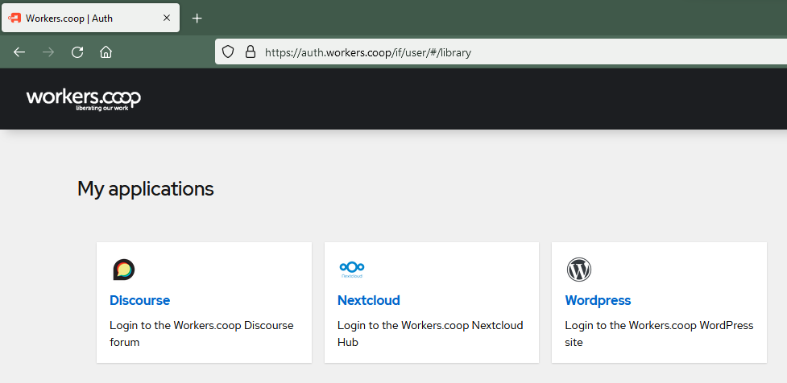

Signing in

To reach the landing page with an overview of all the platforms available to you, head to <https://auth.workers.coop/> (SSO page) and sign in using the credentials you registered with.

Registering for the Discourse Forum

Either click the ‘Discourse’ button on the SSO page or head to <https://forum.workers.coop/> and click log in.

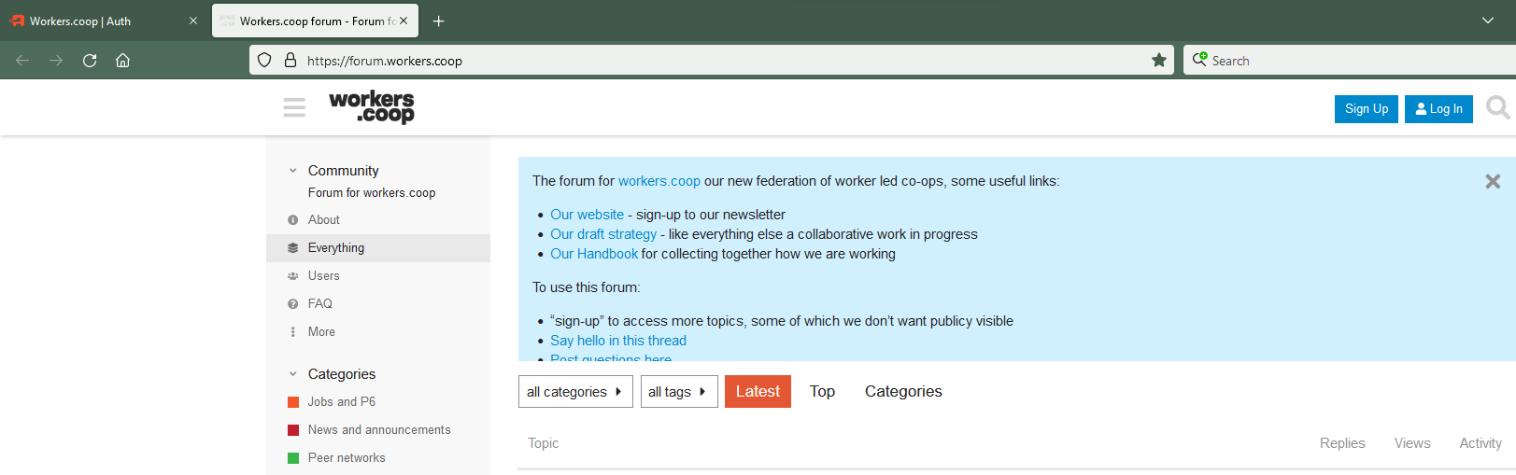

* The engine that powers the SSO is *Authentik*.

You will need to select ‘Login with Workers.coop Auth’ each time you want to sign in*.

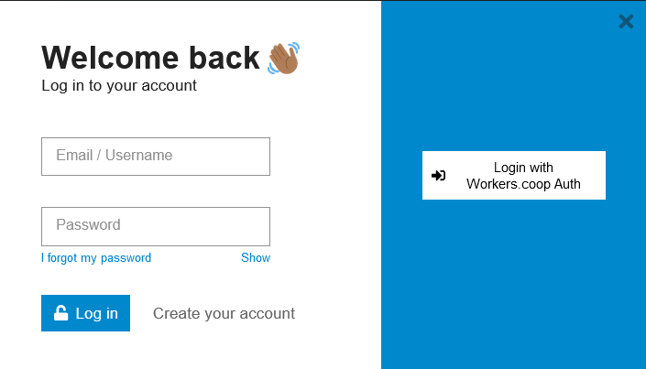

If it is your first time, you should be brought to a create your account landing page, letting you check the availability of your current username or giving you a chance to choose a separate one here, should you wish.

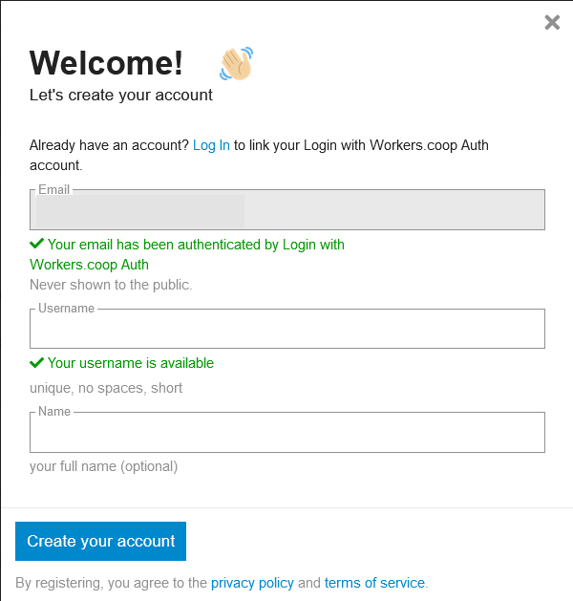

* For those wanting to sign up to only the **Discourse Forum** platform for now, choose ‘Create Your Account’ here instead.

Nextcloud

Creating a New File on Nextcloud

Go to ‘Files’ then click the **+** button. You will have a range of options to choose from. We recommend choosing .docx or .xlsx (up-to-date formats) to ensure the highest chance of compatibility across platforms and between users. You can save them to your ‘Documents’ folder; if you intend to share them with others, you might want to create a dedicated folder.

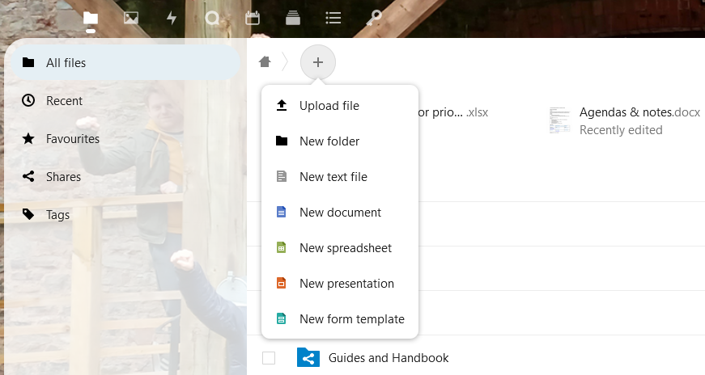

Sharing a File

To the right of the file you wish to share you will see a ‘**<**’ looking share-symbol or a user’s icon (a photo or initial, indicating who shared that file with you). Click it to open the share sidebar; you will find information on whether, with whom and how that file or folder has been shared.

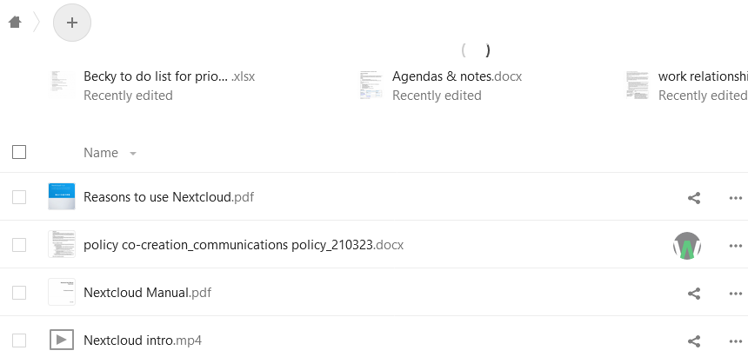

There are multiple share options:

1. Type in the search field; select from the drop-down the name of groups or individual users for whom you want to share it with.

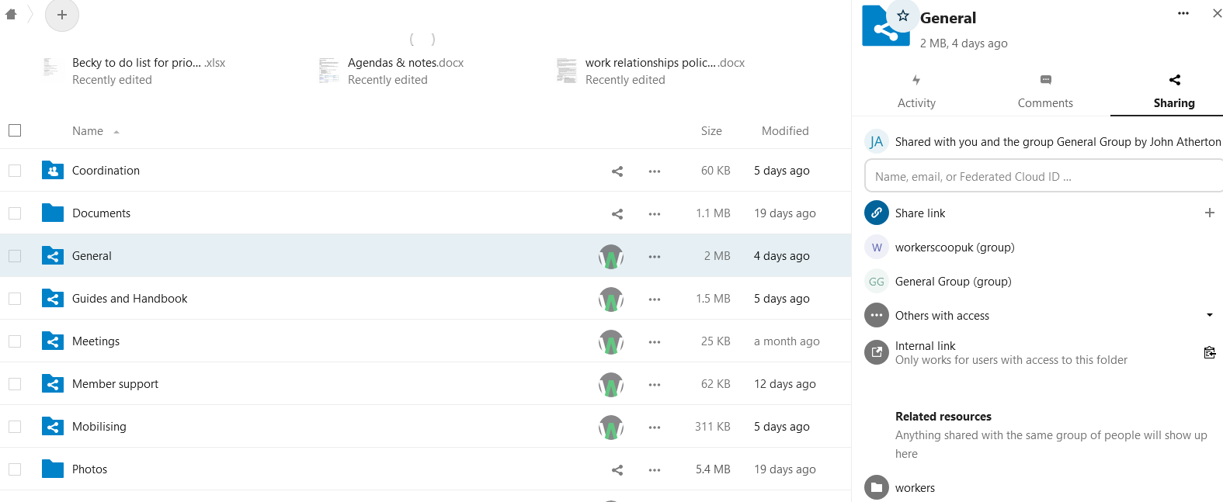

2. To create a private link for internal communications, sensitive information or otherwise, click ‘**Internal link**’ and the permalink will be copied to your clipboard: to share via email, for example. This can serve as a quick reference link or a reminder, say. Note, only the owner or users given access via Option 1 can view it (unless it has been made public).

3. To create a live (public) share link, click ‘**Share link**’. Alternatively copy and paste the URL at the top of the web page.

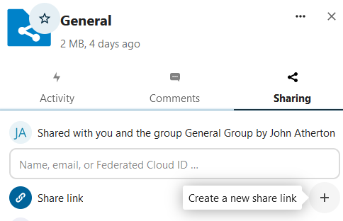

The link will automatically save to your clipboard (click the folder-with-arrow button to copy it again) and further options will be presented:

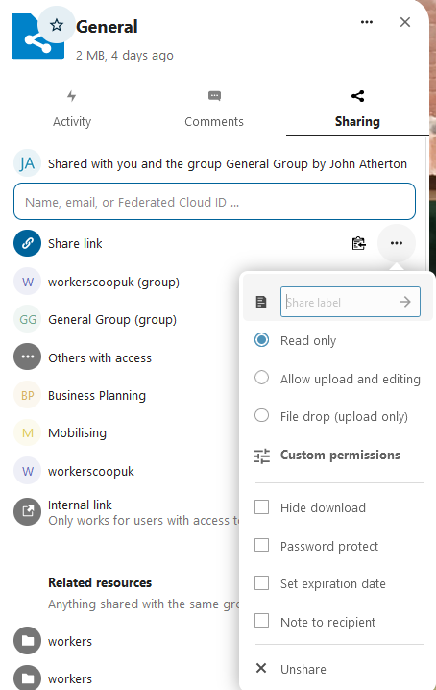

The default setting is Read only. It would be advisable to leave this as is for security and privacy purposes but, should you need, you are able to customise how the file/folder is used via this menu.

Please consult the Federation’s policies on data sharing and GDPR before making anything public. If in doubt, simply use the **Internal link** and give access via the search bar.

Lastly, to make the file/folder private again, click **Unshare**.

Collaborating on a File

The word processing tool powering our Nextcloud* server is OnlyOffice. If you open the file though a browser, you are effectively using this program. Anyone subsequently opening the file online will be able to work alongside you in real time. The files auto-save as you go.

Nextcloud is an open-source cloud-hosting service where the Federation stores and remotely accesses documents. It can interact with many other providers and software, for example OnlyOffice.

OnlyOffice is a versatile free tool empowering anyone to work with a range of programs across multiple devices and operating systems. Through it, members of the Federation can work together on projects online wherever we are. We will look at offline options in the next guide. For now, we will finish here by logging/signing out.

Logging Out

Currently you have to sign out of each individual platform you are logged into. The optimum workflow for this is to leave the SSO/Authentik page till last:

Sign Out of the Forum (Discourse)

On the [Discourse Page](https://forum.workers.coop/), click your icon (a letter or photo) at the top right, then the person icon at the base of the drop-down menu, then ‘Log Out’.

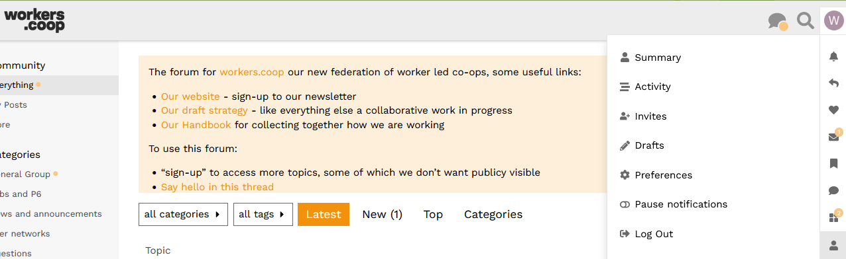

If you had signed in with your SSO, you have the opportunity to sign out via the page you then return to. Just click ‘Log out of authentik’.

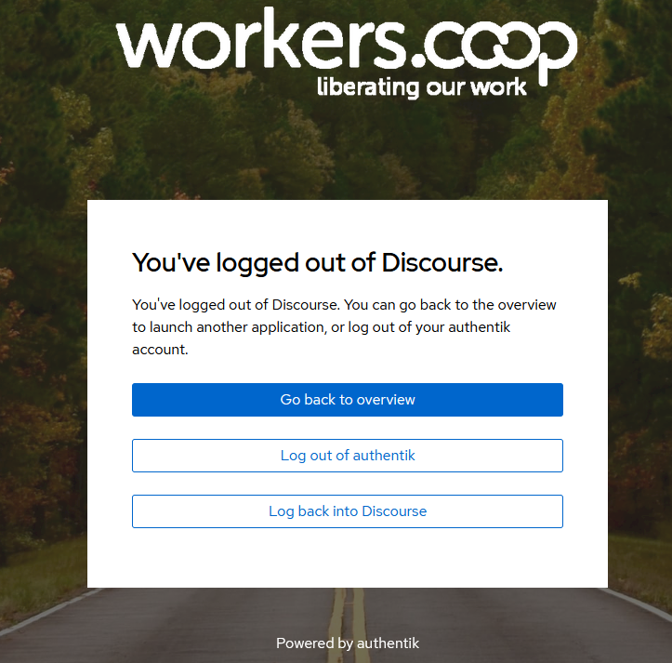

Sign Out of the Workers.coop Hub (Nextcloud)

Similar to the above but with one less step: on the [Nextcloud Page](https://forum.workers.coop/), click your icon at the top right (either a letter or photo), then ‘Log Out.

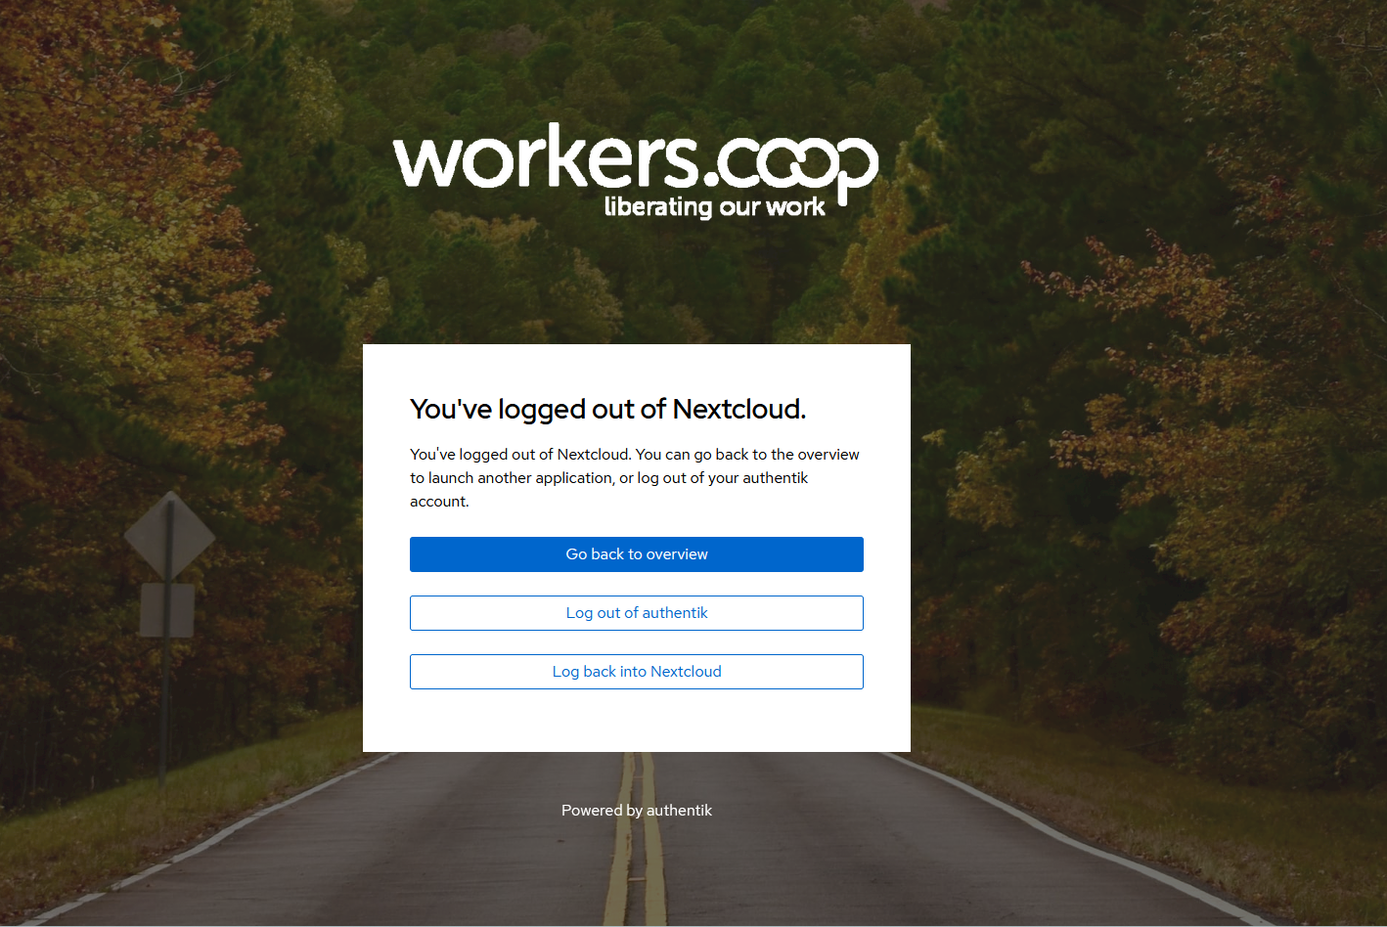

Sign Out of SSO/Authentik

Go to the [SSO Page](https://auth.workers.coop) and click the sign-out button (arrow exiting a square near the the top right). If successful, you will return back to the log-in screen and all other platforms (/applications) will be logged out.

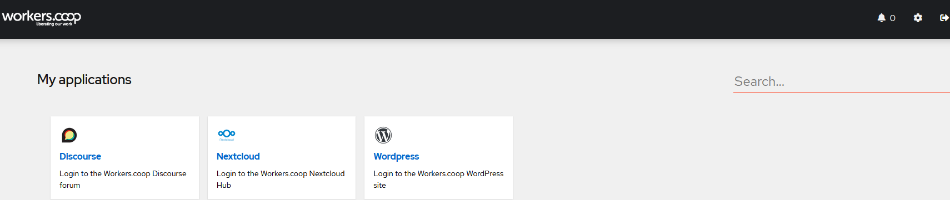

**Welcome to the Federation!**

We look forward to all working together. For any help on the above, please send a message to sam@workers.coop. Our time is shared between our individual co-ops and Federation but we aim to respond to you as soon as we can.